Journal of Medical Microbiology (2015), 64, 565–574
DOI 10.1099/jmm.0.000047
Longitudinal monitoring for respiratory pathogens in
broiler chickens reveals co-infection of Chlamydia
psittaci and Ornithobacterium rhinotracheale
Cindy De Boeck,3 Isabelle Kalmar,3 Annelien Dumont
and Daisy Vanrompay
Correspondence
Department of Molecular Biotechnology, Faculty of Bioscience Engineering, Ghent University,
Coupure Links 653, 9000 Ghent, Belgium
Cindy De Boeck
Cindy.Deboeck@ugent.be
Chlamydia psittaci is prevalent in broiler chicken production. However, the role of C. psittaci in the
respiratory disease complex needs to be clarified. Our aim was to identify the time point when a C.
psittaci infection appeared on a broiler farm and to examine the presence of other respiratory
pathogens at that time. We focused on the ‘major’ respiratory pathogens occurring in Belgian
broilers, namely infectious bronchitis virus (IBV), avian metapneumovirus (aMPV),
Ornithobacterium rhinotracheale, Mycoplasma gallisepticum and Mycoplasma synoviae, and
examined their co-occurrence with C. psittaci on three commercial broiler farms. For all farms, 1-
day-old broilers showed high maternal antibody titres against C. psittaci in the presence of viable
C. psittaci. Maternal antibodies seemed to protect against respiratory signs. Maternal antibodies
declined and clinical outbreaks could be identified serologically even before maternal antibodies
completely disappeared. Mixed infections with genotypes B/C and B/C/D were observed.
Broilers with C. psittaci antibody increases showed conjunctivitis, signs of upper respiratory
disease and dyspnoea. C. psittaci always preceded an O. rhinotracheale infection. Infections with
aMPV, IBV or Mycoplasma spp. were not observed. Evidence was provided that C. psittaci could
occur at an early age in broilers without a predisposing respiratory infection. Both C. psittaci and
O. rhinotracheale should be considered when developing prevention strategies for respiratory
disease in broilers.
INTRODUCTION
and they were able to prove the Hill–Evans postulates
for chicken-derived C. psittaci genotype B and D strains.
Nucleic acid amplification techniques (NAATs) have given
us the opportunity to detect Chlamydia psittaci in a fast,
sensitive and specific way. Moreover, NAATs have allowed
the molecular characterization of C. psittaci. Ever since
applying NAATs, C. psittaci has been detected more often
in chickens. Virulent C. psittaci strains were detected by
NAATs, and isolated from diseased chickens raised in
Australia, Belgium, China, France and Germany (Gaede
et al., 2008; Zhang et al., 2008; Laroucau et al., 2009;
Robertson et al., 2010; Zhou et al., 2010; Yin et al., 2013a).
Recently, C. psittaci was detected in a Belgian chicken
slaughterhouse and in a Belgian chicken hatchery. Zoonotic
transmission occurred at both locations (Dickx et al., 2010;
Dickx & Vanrompay, 2011). Yin et al. (2013a, b) demon-
strated the occurrence of highly and less virulent C. psittaci
strains in broilers raised in Belgium and Northern France,
Moreover, Lagae et al. (2013), found C. psittaci in broiler
breeders, broilers and layers, and their transmission to
farmers. Humans (n52) on the C. psittaci-negative farm
never had respiratory complaints, whilst 25 of 29 (86.2 %)
humans, all working on C. psittaci-positive farms, reported
yearly medical complaints potentially related to psittacosis.
Four (12.5 %) of 31 farmers mentioned in the questionnaire
that they had pneumonia after starting to raise chickens,
which was higher than the yearly rate of 8 : 1000 pneumonia
cases in Belgium. C. psittaci seems to be emerging or re-
emerging in broiler chicken production. However, the role
of C. psittaci in the respiratory disease complex is unclear
and needs to be clarified.
When C. psittaci infects chickens, it is often considered to
co-infect with a virus, another bacterium or even fungi,
although only three such case reports have been described
(Malkinson et al., 1987; Reetz & Schultze, 1995; Shi et al.,
2003). Beeckman et al. (2010) determined the cytokine
responses following C. psittaci infection of chicken macro-
phages. High IL-10 and no transforming growth factor-b4
responses were observed. This could induce macrophage
3These authors contributed equally to this work.
Abbreviations: aMPV, avian metapneumovirus; IBV, infectious bronchitis
virus; MOMP, major outer membrane protein; NAAT, nucleic acid
amplification technique; NDV, Newcastle disease virus; URTD, upper
respiratory tract disease.
Downloaded from www.microbiologyresearch.org by
000047 G 2015 The Authors Printed in Great Britain
565
IP: 137.132.123.69
On: Fri, 29 Jan 2016 06:06:04


C. De Boeck and others
deactivation and NFkB suppression, and thereby could
dampen innate immunity, rendering the birds more
susceptible to other pathogens.
Study concept. One-day-old broiler chickens were monitored until
slaughter according to a previously described study concept for
broiler turkeys (Verminnen et al., 2006; Van Droogenbroeck et al.,
2011). Observations, sampling age, specimens and tests used are
presented in Table 2. The occurrence of conjunctivitis, signs of upper
respiratory tract disease (URTD) and dyspnoea was scored weekly at
barn level. Mortality and antibiotic use were registered daily at barn
level. At age 1 day, 20 randomly selected 1-day-old toms were
individually tagged with a leg number and their back was marked
with blue ink to allow on-sight, rapid identification, as they were
allowed to move freely throughout the barn. Broilers were sampled
at age 1 day, and at 7, 14, 21, 28, 35 and 40 days. Bio-aerosol
monitoring was performed at the same times plus just before
stocking, in a cleaned and disinfected barn. The following samples
were collected: (1) blood for C. psittaci, O. rhinotracheale, M.
gallisepticum, M. synoviae and aMPV serology; (2) pharyngeal swabs
and air samples for C. psittaci isolation, and subsequent molecular
characterization; and (3) pharyngeal swabs for (i) O. rhinotracheale
16S rDNA PCR, (ii) M. gallisepticum/M. synoviae real-time PCR, (iii)
real-time reverse transcription (RT)-PCR for aMPV subtypes A–D
and (iv) RT-PCR for IBV; samples were examined retrospectively,
when the animals were already slaughtered. First, ELISAs were
performed in order to test all sera for a three- to fourfold rise in
antibody titre in order to detect any ongoing respiratory infection. At
the seroconversion time point, attempts were made to detect the
respiratory pathogens. The latter study concept was also used by Van
Loock et al. (2005).
Virulent C. psittaci strains are found more often in broilers
and recently Sachse & Laroucau (2014) presented evidence
for the existence of a new member of the order Chlamydiales,
namely Chlamydia gallinacea sp. nov., comprising strains
from poultry. The present study focuses on the ‘major’ well-
recognized respiratory pathogens occurring in Belgian
broilers, namely infectious bronchitis virus (IBV), avian
metapneumovirus (aMPV), Ornithobacterium rhinotracheale,
Mycoplasma gallisepticum and Mycoplasma synoviae, and
examines their co-occurrence with C. psittaci. Belgian chicken
farms are like those in the rest of Western European and US
chicken production units, i.e. modern industrial farms. We
do implement Sanitel – a traceability system that tracks
products through the entire supply chain. It is a prerequisite
to an effective supply chain and quality management. The
present study identified the time point when a C. psittaci
infection appeared on three broiler chicken farms and
examined the presence of other respiratory pathogens from
production onset until slaughter in order to find concurrent
respiratory pathogens.
Sample processing prior to analyses. Blood samples were
collected by venipuncture of the cutaneous ulnar vein (vena ulnaris)
and stored overnight at room temperature. Sera were collected after
centrifugation (300 g, 10 min, 48 uC), pre-treated with kaolin to
remove ELISA background activity (Novak et al., 1993) and stored at
220 uC until tested for the presence of antibodies.
METHODS
Farm management. Farm selection was based on (1) only broiler
chickens present, (2) minimum of 10 000 chickens per barn and (3)
the farmer’s cooperation. The study was conducted in one, ad
randomly chosen barn of two medium size (total capacity 60 000
broilers; farms A and B) and one large size (total capacity 120 000
broilers; farm C) Belgian farms located in East Flanders.
Rayon-tipped, aluminium shaft swabs (Copan; Fiers) were used to
sample the pharynges. Swabs for C. psittaci culture and subsequent
molecular typing of isolates contained 2 ml Chlamydia transport
medium (Vanrompay et al., 1992) and were transported at 4 uC.
Upon arrival in the laboratory, swabs were shaken for 1 h at 4 uC and
centrifuged (10 min, 2790 g, 4 uC). Supernatants were stored at
280 uC until inoculation on cell culture. Swabs for different PCRs
contained 2 ml RNA/DNA stabilization reagent (Roche) and were
transported at 4 uC. Swabs were shaken for 1 h at room temperature.
DNA extraction was performed as described by Van Loock et al.
(2005). DNA extracts were stored at 280 uC until tested. The amount
of live C. psittaci in the air was determined by the use of a MAS-100
All farms applied an all-in/all-out management schedule with a
sanitary service period of 2 weeks between slaughter and restocking
(six broods per year) during which the barns were cleaned and
disinfected. Farms tested negative for Salmonella. Salmonella testing
was routinely performed by the Federal Agency for Food Safety upon
arrival of the chickens and 3 weeks before slaughter according to EU
regulations (2160/2003, frequency; 646/2007, broilers). Samples were
examined by culture and serotyping was performed if positive.
During the first week, broilers were raised at an ambient temperature
of 29–32 uC, reducing the temperature slowly to 23–21 uC by the time
the birds were shipped. Mechanical ventilation was regulated as
required. The farmers checked the climate four times a day. The
climate was regulated using a computer-controlled cooling/heating/
ventilation system (Barn computer installation; Stalinrichting A & J
De Jaeger). Hens and toms were raised in the same climate-controlled
barn with a soft floor covered with crushed flax cores. The lighting
schedule was 24 h light during the first 36 h (24 h light : 0 h dark),
18 h light : 6 h dark at age 3–14 days, followed by a gradual increase
in hours of light (+15 min per day) to reach 20 h light : 4 h dark at
age 21 days, which was maintained until slaughter age. At age 35–
36 days, broiler density was reduced by removal of approximately
one-third of the remaining birds, for which the rearing period was
thus ~1 week shorter. All birds were vaccinated against Newcastle
disease virus (NDV), IBV and infectious bursitis virus (Gumboro
disease). All animals were treated according to the advice of the
company veterinarian. Additional details on farm management and
vaccination against respiratory disease in breeders (origin of the
broilers under study) and broilers are presented in Table 1.
EcoSampler (Merck) in combination with ChlamyTrap 1 air
collection medium, as described by Van Droogenbroeck et al.
(2009). Samples were stored at 280 uC until inoculation on cell
culture.
ELISAs. Sera were analysed by a major outer membrane protein
(MOMP)-based C. psittaci ELISA (Verminnen et al., 2006). Anti-
MOMP IgG (H+L) titres were determined using a standard protocol
(twofold dilutions starting at 1/100) and micro-well plates coated
with recombinant C. psittaci MOMP prepared in transient transfected
COS-7 cells (Vanrompay et al., 1998). In addition, O. rhinotracheale,
M. gallisepticum/M. synoviae, IBV and aMPV antibody titres were
determined using four indirect commercial ELISAs (FlockChek ORT,
MG/MS, APV and IBV Antibody Test kits; IDEXX). All tests were
performed according to the manufacturer’s guidelines.
Culture and genotyping of C. psittaci. Pharyngeal swabs and air
samples were examined for the presence of viable C. psittaci. Culture
was performed using BGM (buffalo green monkey) cells, identifying
the organism by direct immunofluorescence staining (IMAGEN;
Downloaded from www.microbiologyresearch.org by
566
Journal of Medical Microbiology 64
IP: 137.132.123.69
On: Fri, 29 Jan 2016 06:06:04

Table 1. Information on farm management and vaccination against respiratory pathogens in breeders and broilers (WVPA- Belgie¨ , 2010).
Farm
A
B
C
Age of breeders (weeks)
Antibiotic treatment of breeders
Respiratory vaccines: breeders
NDV
52.5
53
49
None
None
None
Nobilis ND clone 30 day 12
Nobilis ND clone 30 day 14
Hipraviar La Sota day 12
Nobilis IB M41+D274 and NC clone 30 day 56 Nobilis ND clone 30 day 56
Nobilis RT+IB Multi+ND+EDS day 119 Nobilis IB Multi+ND day 119
Hipraviar La Sota day 56
Nobilis RT+IB Multi+ND+EDS day 119
IBV
Poulvac IB primer day 1; Nobilis IB 4-91 day 12; Nobilis IB Ma5 day 28; Nobilis IB Ma5 day 84; Poulvac IB primer day 1; Nobilis IB 4-91 day
Nobilis IB Multi+ND day 56; Poulvac IB QX
Nobilis IB Multi+ND day 119
12; Poulvac IB QX day 70; Nobilis RT+IB
Multi+ND+EDS day 119
day 70; Nobilis RT+IB Multi+ND+EDS day
119
aMPV
Nobilis RTV 8544 day 84
None
Nobilis RTV 8544 day 84
Nobilis RT+IB Multi+ND+EDS day 119
None
Nobilis RT+IB Multi+ND+EDS day 119
Infectious laryngotracheitis virus
Disinfection of broiler barn
Poulvac ILT day 42
Poulvac ILT day 70
None
Walls and floor: 1000 l H₂O+50 l formol+5 l
Walls and floor: 2 l Virocid in 400 l H₂O
Walls and floor: 25 l formol in 250 l H₂O;
fumigation: 25 l formol+5 l MS Megades
Hi-Logic
900
Dimension of broiler barn (m²)
No. of broilers in barn
Stocking density of broilers (m²²
Slaughter age (days)
800
14 000
17
1600
30 000
18
18 000
20
)
40
42
41
Respiratory vaccines: broilers
NDV
Nobilis ND C2 day 1
Nobilis ND C2 day 1
Nobilis ND C2 day 1
Nobilis ND clone 30 day 16
Poulvac IB primer day 1
Nobilis ND clone 30 day 18
Poulvac IB primer day 1
Nobilis ND clone 30 day 18
Poulvac IB primer day 1
IBV
Suppliers of vaccines: Nobilis vaccines (MSD Animal Health), Poulvac vaccines (Zoetis), Hipraviar vaccine (Hipra Benelux). Suppliers of disinfectants: Hi-Logic (Agro 2000), Virocid (CID Lines)
and MS Megades (Schippers).
Downloaded from www.microbiologyresearch.org by
IP: 137.132.123.69
On: Fri, 29 Jan 2016 06:06:04


C. De Boeck and others
Table 2. Experimental setup
Farm
Observations and sampling
(no. of animals
[
Pharyngeal swabsD age (days)
]
[
Bloodd age (days)
]
Clinical signs and mortality
Air in barns* (days)
tested)
A (n520)
B (n520)
C (n520)
Daily
Daily
Daily
0, 1, 7, 14, 21, 28, 35, 40
0, 1, 7, 14, 21, 28, 35, 40
0, 1, 7, 14, 21, 28, 35, 40
1, 7, 14, 21, 28, 35, 40
1, 7, 14, 21, 28, 35, 40
1, 7, 14, 21, 28, 35, 40
1, 7, 14, 21, 28, 35, 40
1, 7, 14, 21, 28, 35, 40
1, 7, 14, 21, 28, 35, 40
*For C. psittaci culture and molecular characterization.
DFor (1) C. psittaci culture and molecular characterization, (2) O. rhinotracheale 16S rDNA PCR, (3) M. synoviae/M. gallisepticum real-time PCR,
(4) real-time RT-PCR for aMPV subtypes A–D and (5) RT-PCR for IBV.
dFor antibody determination (ELISAs) against C. psittaci, O. rhinotracheale, M. synoviae, M. gallisepticum, aMPV and IBV.
Oxoid) at 6 days post-inoculation. C. psittaci-positive cells were
enumerated in five randomly selected microscopic fields (6600,
Eclipse TE2000-E; Nikon) and results were scored from 0 to 5. A score
of 0 indicated that no C. psittaci was present; a score of 1 was given
when a mean of 1–5 non-replicating elementary bodies was present;
scores of 2, 3, 4 and 5 were given when means of 1–5, 6–10, 11–20 and
.20 inclusion (elementary and replicating reticulate bodies) positive
cells, respectively, were present.
Nevertheless, broilers were not treated again. For farms B
and C, conjunctivitis, signs of URTD and dyspnoea were
present at age 35 days. However, by that time broilers on
both farms had already been treated with amoxicillin (days
27–29 on both farms) for signs of URTD and severe dyspnoea
(farm B) or signs of URTD and conjunctivitis (farm C). In
both farms, respiratory disease worsened towards the end of
the rearing period (42 days, farm B; 41 days, farm C), but
broilers were not treated. At the end of the rearing period,
cumulative mortality was comparable for all farms (3.17,
3.54 and 3.17 % for farms A, B and C, respectively).
DNA extraction on cell culture harvest was performed as described by
Wilson et al. (1996). Outer membrane protein A (ompA) genotyping
was performed by a C. psittaci genotype-specific real-time PCR (Geens
et al., 2005). The latter PCR distinguished genotypes A–F and E/B using
genotype-specific primers, genotype-specific probes and competitor
oligonucleotides.
Serology
PCR for O. rhinotracheale, Mycoplasma spp., aMPV or IBV.
O. rhinotracheale 16S rDNA was detected as described previously by
Hung and Alvarado (2001). M. gallisepticum and M. synoviae 16S
rDNA was detected by a LSI VetMAx Triplex Avian Mycoplasmosis –
M. gallisepticum & M. synoviae Real-Time PCR kit (Life Technologies).
aMPV was identified by real-time RT-PCR using a LSI VetMAX Avian
Metapneumovirus Real-Time PCR kit (Life Technologies) for the
detection of aMPV subgroups A, B and C together with an additional
combination of primers and probe designed by Guionie et al. (2007) for
the detection of aMPV subgroup D. Primers used and TaqMan probes
were based on the conserved regions of the nucleotide sequences
available for the G genes of aMPV- A, -B and -D, and for the SH gene of
aMPV- C . As we could not find antibodies for IBV, swabs were not
examined further.
Results are presented in Figs 1, 2 and 3. Mycoplasma spp.
antibodies were only detected at age 1 day in four of 20
(20 %) broilers of farm C. Antibodies against O. rhino-
tracheale were detected on farms B and C. For farm B,
antibodies against O. rhinotracheale were present at age
1 day (three of 20 broilers; 15 %) and 28 days (one of 20
broilers; 5 %). For farm C, antibodies against O. rhino-
tracheale were present at age 35 days (four of 20 broilers;
20 %). Antibodies against aMPV were noticed on all farms,
in 1- as well as 7-day-old broilers. For farms A, B and C,
eight of 20 (40 %), one of 20 (5 %) and 14 of 20 (70 %) 1-
day-old broilers were, respectively, seropositive for aMPV.
C. psittaci antibodies were found on all farms. The curves
for the percentage of seropositives were similar, showing
almost identical numbers of seropositives at age 1 day and
at slaughter, with a clear decrease in the number of
seropositives in between.
RESULTS
Clinical signs, mortality and antibiotic use
Clinical signs, mortality and antibiotic use are presented in
Figs 1, 2 and 3. Conjunctivitis, signs of URTD and dyspnoea
were present on all farms. On all farms, clinical signs
were first observed at age 7 days. At that time, 5 % (farms
B and C) and 10 % (farm A) of the broilers showed mild
dyspnoea. For farm A, conjunctivitis, signs of URTD and
dyspnoea were present at age 21 days, leading to amoxicillin
(Octacillin; Eurovet) treatment (days 23–24 and 27–28) and
clinical improvement towards age 28 days. However, clinical
signs reappeared after treatment stopped and even wor-
sened towards the end of the rearing period (40 days).
Identification of respiratory pathogens
Results are presented in Figs 1, 2 and 3. IBV RT-PCR was
not performed, as all sera were negative. PCR assays for
aMPV and for M. gallisepticum and M. synoviae were
negative. Broilers in farms B and C became infected with O.
rhinotracheale. The 1- and 28-day-old seropositive broilers
of farm B were, respectively, negative and positive (two of
20; 10 %) in the O. rhinotracheale PCR. The 35-day-old
seropositive broilers of farm C became positive (eight of
Downloaded from www.microbiologyresearch.org by
568
Journal of Medical Microbiology 64
IP: 137.132.123.69
On: Fri, 29 Jan 2016 06:06:04


Respiratory pathogens in broiler chickens
(a)
Amoxicillin
(d23–24 and d27–28)
100
80
60
40
20
0
500
B
C
D
B
C
D
C
D
C
D
C
D
C
D
400
300
200
100
0
C
D
B-D (1)
B-C-D (1) B-C-D (1)
C-D (1)
14
C-D (0)
21
C-D (0)
28
C-D (1)
35
C-D (2) Air samples* (culture score)
1
7
40 Age (days)
Titre (mean+_{SEM})
Culture-positive (%)+genotype
Seroprevalence (%)
Culture score (mean positive+_{SEM})
PCR_{aMPV}: neg
*Letters indicate genotypes in air
(b) 50
500
400
300
200
100
0
40
30
20
10
0
PCR_{aMPV}: neg
1
7
14
21
28
35
40
Age (days)
Ms/Mg seroprevalence (%)
Ms/Mg titre (mean+_{SEM})
aMPV seroprevalence (%)
aMPV titre (mean+SEM)
ORT seroprevalence (%)
ORT titre (mean+SEM)
35
30
25
20
15
10
5
(c)
6
4
2
0
0
1
7
14
21
28
35
40
Age (days)
Cumulative mortality (%)
Signs of URTD
Conjunctivitis/blepharitis
Dyspnoea
Barn temperature – norm (°C)
Barn temperature – measured (°C)
Fig. 1. Farm A. (a) Serology of C. psittaci, and its presence in pharyngeal swabs and air samples (culture and genotype-specific
PCR). d, Day. (b) Serology of M. gallisepticum/M. synoviae (Ms/Mg), aMPV and O. rhinotracheale (ORT), and their presence in
pharyngeal swabs (PCR). (c) Mortality, clinical observations and ambient temperature.
Downloaded from www.microbiologyresearch.org by
http://jmm.sgmjournals.org
569
IP: 137.132.123.69
On: Fri, 29 Jan 2016 06:06:04
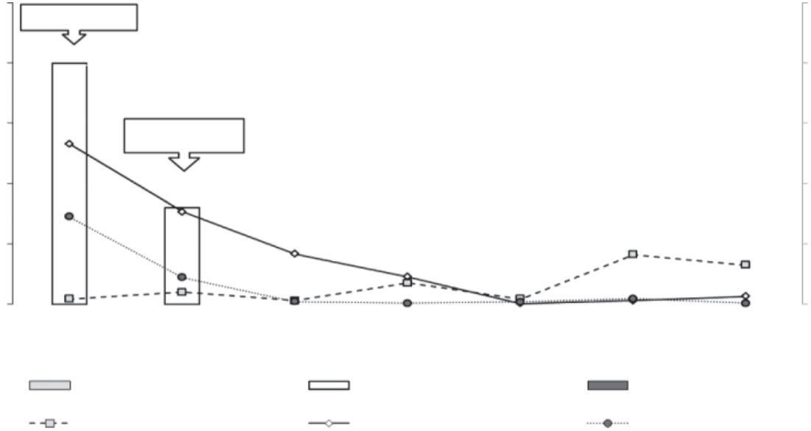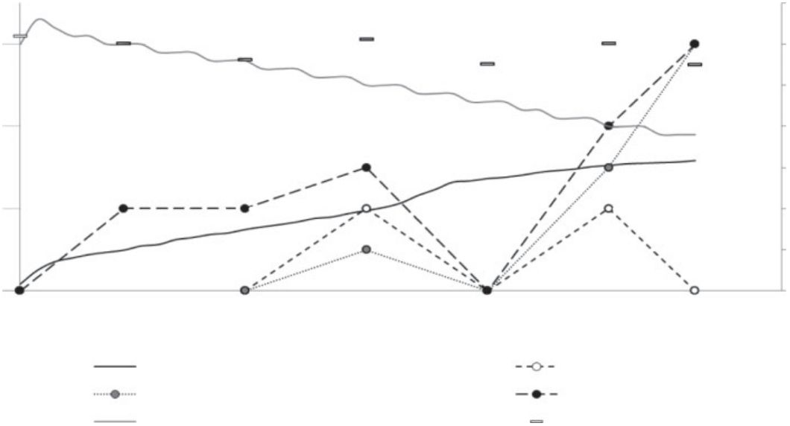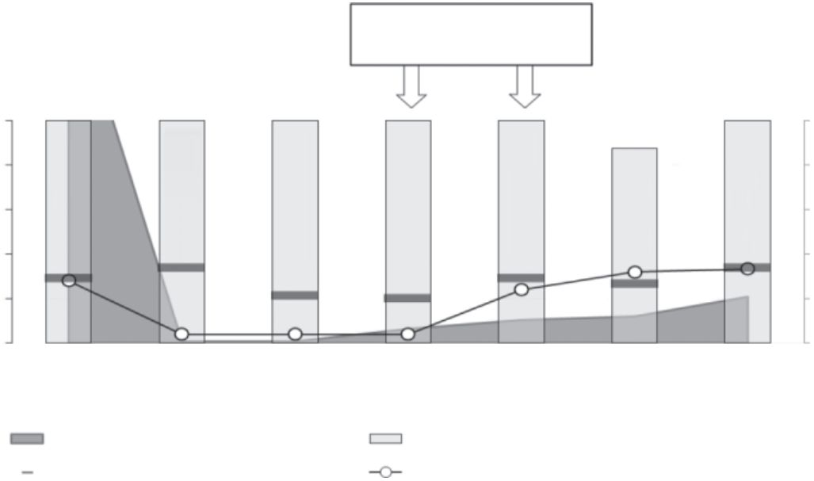

C. De Boeck and others
(a)
Amoxicillin (d27–29)
100
80
500
400
300
200
100
0
B
C
B
C
C
B
C
B
C
60
40
20
0
B
C
B
C
B-C (1)
B-C (1)
1
C (2)
7
B-C (3)
14
B-C (0)
21
B-C (0)
28
B-C (3)
35
C (2) Air samples* (culture score)
42 Age (days)
Titre (mean+_{SEM})
Culture-positive (%)+genotype
Seroprevalence (%)
*Letters indicate genotypes in air
Culture score (mean positive+_{SEM})
(b)
PCR_{ORT}: neg
PCR_{aMPV}: neg
500
400
300
200
100
0
50
40
30
20
10
0
PCR_{aMPV}: neg
^{pos PCR}_{ORT}: 10%; 2/20
1
7
14
21
28
35
40
Age (days)
Ms/Mg seroprevalence (%)
Ms/Mg titre (mean+_{SEM})
aMPV seroprevalence (%)
aMPV titre (mean+SEM)
ORT seroprevalence (%)
ORT titre (mean+SEM)
35
30
25
20
15
10
5
(c)
6
4
2
0
0
Age (days)
1
7
14
21
28
35
42
Cumulative mortality (%)
Signs of URTD
Conjunctivitis/blepharitis
Dyspnoea
Barn temperature – norm (°C)
Barn temperature – measured (°C)
Fig. 2. Farm B. (a) Serology of C. psittaci, and its presence in pharyngeal swabs and air samples (culture and genotype-specific
PCR). d, Day. (b) Serology of M. gallisepticum/M. synoviae (Ms/Mg), aMPV and O. rhinotracheale (ORT), and their presence in
pharyngeal swabs (PCR). (c) Mortality, clinical observations and ambient temperature.
Downloaded from www.microbiologyresearch.org by
570
Journal of Medical Microbiology 64
IP: 137.132.123.69
On: Fri, 29 Jan 2016 06:06:04
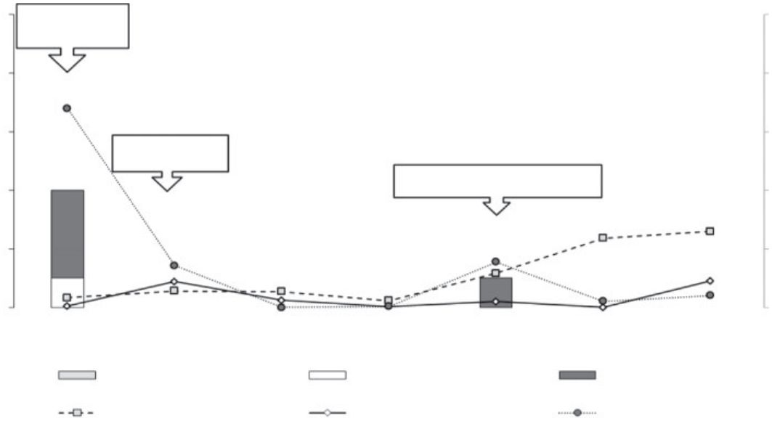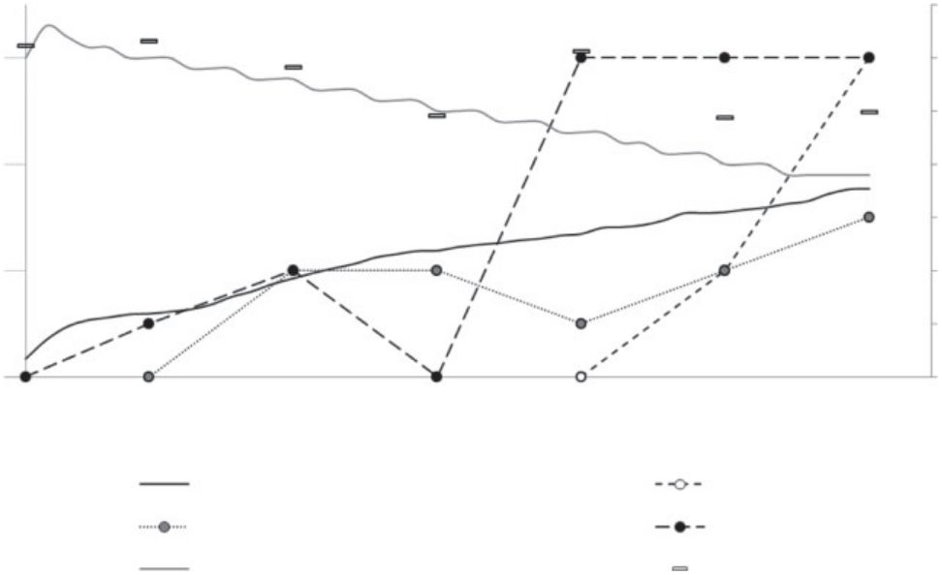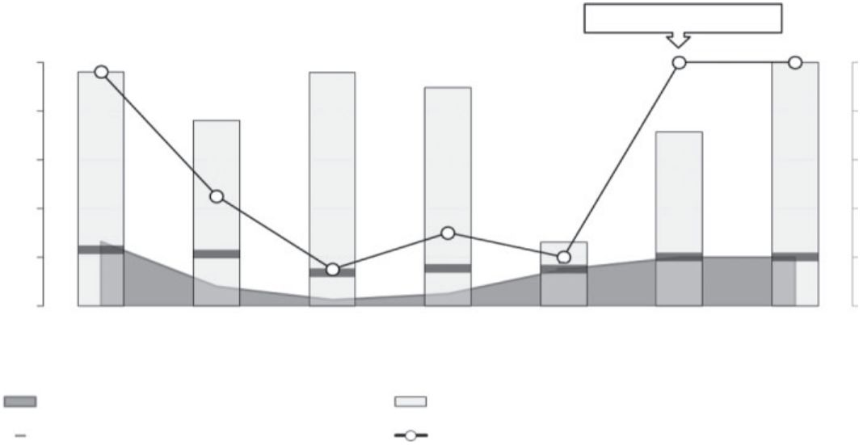

Respiratory pathogens in broiler chickens
20; 40 %) in the O. rhinotracheale PCR and three of
them (15 %) were still positive at slaughter. Thus, an O.
rhinotracheale infection was first noticed towards the end
of the rearing period, at 4 (farm B) or 5 (farm C) weeks of
age.
D274 at age 1 day. They remained seronegative throughout
the rearing period. Thus, they must have been protected or
IBV did not occur on these farms. On farm C, we found
maternal antibody titres against Mycoplasma, as no
Mycoplasma DNA could be detected at that time. Thus,
breeders must have been infected by Mycoplasma spp.
However, the infection caused no clinical disease in
breeders and they remained untreated. Maternal antibodies
had disappeared at age 7 days and broilers remained
seronegative until slaughter. On farm B, we found maternal
antibody titres against O. rhinotracheale, as no O. rhino-
tracheale DNA could be detected at that time. Breeders
received no O. rhinotracheale vaccine. Thus, breeders must
have been infected by O. rhinotracheale. However, the
infection caused no clinical disease in breeders and they
remained untreated. Maternal antibodies against O. rhino-
tracheale had disappeared at age 7 days, and broilers
experienced an O. rhinotracheale infection 3 weeks later as
demonstrated by both ELISA (seroconversion) and PCR.
Around the same time, broilers of farm C also experienced
an O. rhinotracheale infection, as revealed by ELISA
(seroconversion) and PCR.
Broilers in all three farms became infected with C. psittaci.
In fact, C. psittaci was present in 1-day-old broilers, but sero-
conversion only occurred ~3–4 weeks of age, just before
the occurrence of an O. rhinotracheale infection. Viable C.
psittaci genotypes B and D (farm A), B and C (farm B), and
C (farm C) were found in the empty, cleaned and disinfected
barns. For farm A, genotype B was no longer discovered at
age 14 days. However, genotype C had appeared at age 1 day
and stayed, together with genotype D, present until slaughter.
Genotypes B and C were present in broilers and in the air
of farm B until the animals reached age 35 and 42 days,
respectively. Genotype C was present during the whole rearing
period in both broilers and air of farm C. The number of
culture-positive broilers ranged from 87.5 to 100 % (farm
A), from 26.1 to 100 % (farm B) and from 37.5 to 91.3 %
(farm C). Thus, C. psittaci culture-positive chickens were
transported to the slaughterhouse at the end of all rearing
periods, which is an important finding regarding the zoo-
notic potential of C. psittaci.
Recently, we found virulent C. psittaci strains in Belgian
and French broilers, and, as in turkeys, C. psittaci could be
involved in the multi-factorial aetiology of respiratory
infections in commercial chickens (Van Loock et al., 2005).
For all farms, 1-day old broilers showed relatively high
maternal antibody titres against C. psittaci in the presence
of viable C. psittaci. This indicates vertical transmission,
which is known to occur in chickens (Wittenbrink et al.,
1993), and/or insufficient cleaning/disinfection, as C.
psittaci was found in all empty barns, even before stocking.
However, maternal antibodies seemed to protect against
respiratory signs. Protection by maternal antibodies against
C. psittaci has been demonstrated previously during an
experimental infection in turkeys (Van Loock et al., 2004).
DISCUSSION
NDV, avian influenza virus, aMPV and IBV are the viruses
that most frequently affect the respiratory tract of broilers,
and thus might interact with C. psittaci. Vaccination of
broilers and/or broiler breeders is the main approach to
control these economically important viral pathogens
(Jones, 2010; Jackwood, 2012; Ou & Giambrone, 2012).
O. rhinotracheale is a primary bacterial pathogen of broilers
(van Veen et al., 2000). Currently, 18 O. rhinotracheale sero-
types designated A–R have been identified, with seroptype A
being highly prevalent in most broiler-producing countries
(Numee et al., 2012). Clinical disease in broilers is less severe
than in turkeys, and involves sneezing, rhinitis and facial
oedema. Nevertheless, infections in broiler chickens can
cause economic losses due to increased mortality, growth
retardation and increased slaughterhouse condemnation
rates. An O. rhinotracheale serotype A vaccine has been
registered for use in broiler breeders, but is still not widely
used, although De Herdt et al. (2012) presented evidence for
the improved performance of broilers originating from O.
rhinotracheale-vaccinated breeders.
Maternal antibodies declined and clinical outbreaks could
be identified serologically noticed even before maternal
antibodies completely disappeared. Mixed infections with
genotypes B/C and B/C/D were observed, which is not
uncommon in poultry (Dickx & Vanrompay, 2011; Lagae
et al., 2013). When a mixed infection occurred, the cumulative
mortality augmented faster (quicker above 2 %). However,
we have no proof that this observation was due to the mixed
C. psittaci infection.
Broilers with antibody increases showed conjunctivitis,
signs of URTD and dyspnoea, and according to the
company veterinarian had to be treated with amoxicillin.
However, this penicillin antibiotic is certainly not the
choice for treating C. psittaci. Moreover, Chlamydia enters
a viable, non-dividing and non-infectious state (historically
termed persistence and more recently referred to as the
chlamydial stress response) when exposed to penicillin G in
culture. Notably, penicillin G-exposed Chlamydiae can re-
enter the normal developmental cycle upon drug removal
(Goellner et al., 2006; Kintner et al., 2014). The latter
We found antibody titres against aMPV on all farms. These
were most likely maternal antibodies as: (i) broilers were
not vaccinated against aMPV, (ii) no viral RNA could be
detected at that time in broilers and (iii) breeders were
immunized twice against aMPV. Maternal antibodies
against aMPV had disappeared at age 14 days and broilers
remained uninfected until slaughter. All examined broilers
were seronegative for IBV, although they received an IBV
primer containing the attenuated IBV strains H120 and
Downloaded from www.microbiologyresearch.org by
http://jmm.sgmjournals.org
571
IP: 137.132.123.69
On: Fri, 29 Jan 2016 06:06:04

C. De Boeck and others
(a)
100
500
400
300
200
100
0
C
80
60
Amoxicillin (d27–29)
C
C
C
40
20
0
C
C
C
C (1)
1
C (>5)
7
C (>5)
14
C (0)
21
C (0)
28
C (0)
35
C (0) Air samples* (culture score)
41 Age (days)
C (2)
Titre (mean+_{SEM})
Culture-positive (%)+genotype
Seroprevalence (%)
Culture score (mean positive+_{SEM})
*Letters indicate genotypes in air
PCR_{aMPV}: neg
PCR_{Ms/Mg}: neg
Ms/Mg
(b)
1000
750
100
80
60
40
20
0
^{PCR}_{aMPV}: neg
pos PCR_{ORT}: 40%; 8/20
pos PCR_{ORT}:
15%; 3/20
500
250
0
41
Age (days)
1
7
14
21
28
35
40
Ms/Mg seroprevalence (%)
aMPV seroprevalence (%)
ORT seroprevalence (%)
Downloaded from www.microbiologyresearch.org by
IP: 137.132.123.69
Ms/Mg titre (mean+_{SEM})
aMPV titre (mean+_{SEM})
ORT titre (mean+_{SEM}
)
35
30
25
20
15
10
5
(c)
6
4
2
0
0
Age (days)
1
7
14
21
28
35
41
Cumulative mortality (%)
Signs of URTD
Conjunctivitis/blepharitis
Dyspnoea
Barn temperature – norm (°C)
Barn temperature – measured (°C)
572
Journal of Medical Microbiology 64
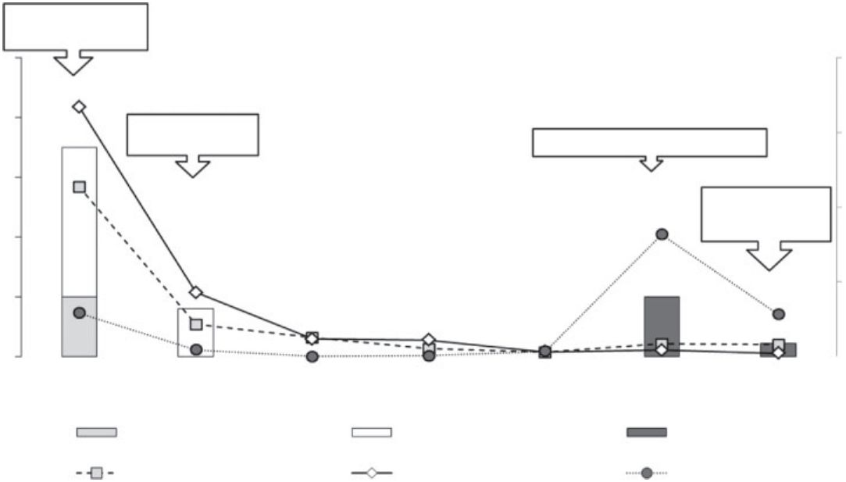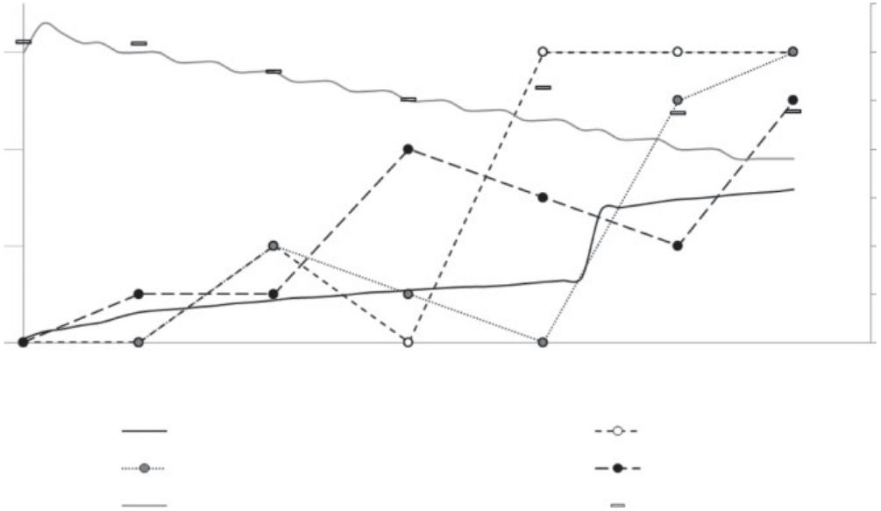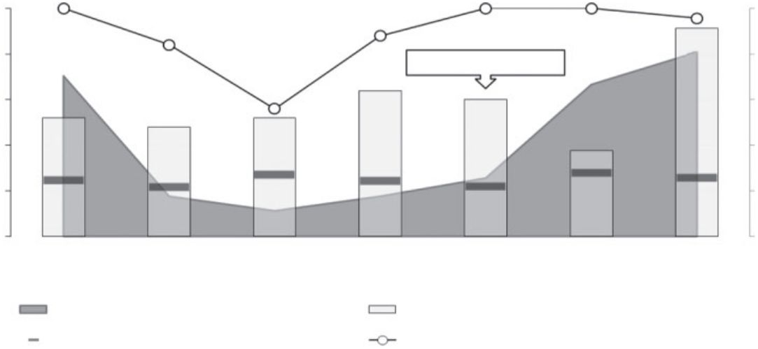

Respiratory pathogens in broiler chickens
Fig. 3. (a) Serology of C. psittaci, and its presence in pharyngeal swabs and air samples (culture and genotype-specific PCR).
d, Day. (b) Serology of M. gallisepticum/M. synoviae (Ms/Mg), aMPV and O. rhinotracheale (ORT), and their presence in
pharyngeal swabs (PCR). (c) Mortality, clinical observations and ambient temperature.
apparently happened as demonstrated by the reaugmenting
pharyngeal culture scores upon drug removal, resulting in
an ongoing infection until slaughter.
psittaci could assist in determining an optimal vaccination
time point in broilers. Vaccination of breeders and/or
broilers against these pathogens together with perhaps bio-
aerosol monitoring as a non-invasive infectious disease
monitoring system could improve broiler performance.
There might be a pathogenic interaction between C. psittaci
and other viral and/or bacterial respiratory pathogens.
Interactions between respiratory pathogens have already been
demonstrated for M. gallisepticum and NDV in experiment-
ally infected chickens (reviewed by Kleven, 1998) and for C.
psittaci and aMPV in experimentally infected turkeys (Van
Loock et al., 2006). On one farm, respiratory signs appeared
together with a proven C. psittaci infection. We could not
detect an O. rhinotracheale infection on farm A, perhaps
due to the antibiotic treatment at days 23–24. On the other
two farms, respiratory signs always appeared together with
a proven C. psittaci and O. rhinotracheale infection. C. psittaci
always preceded O. rhinotracheale. This might suggest an
association between C. psittaci and O. rhinotracheale. C.
psittaci infections could weaken the health of broilers, making
them more susceptible to O. rhinotracheale infections. The
same has been observed in turkeys (Van Loock et al., 2005;
Van Droogenbroeck et al., 2011). Thus, both C. psittaci and
O. rhinotracheale should be considered when developing
prevention strategies for respiratory disease in broilers.
ACKNOWLEDGEMENTS
The study was funded by the Federal Public Service of Health, Safety
of the Food Chain and Environment (convention RF-11/6245
MINSPEC-PRO), Ghent University (IOF10/STEP/002) and MSD
Animal Health (Boxmeer, The Netherlands).
REFERENCES
Beeckman, D. S., Rothwell, L., Kaiser, P. & Vanrompay, D. C. (2010).
Differential cytokine expression in Chlamydophila psittaci genotype
A-, B- or D-infected chicken macrophages after exposure to
Escherichia coli O2 : K1 LPS. Dev Comp Immunol 34, 812–820.
Croxatto, A., Rieille, N., Kernif, T., Bitam, I., Aeby, S., Pe´ ter, O. &
Greub, G. (2014). Presence of Chlamydiales DNA in ticks and fleas
suggests that ticks are carriers of Chlamydiae. Ticks Tick Borne Dis 5,
359–365.
De Herdt, P., Broeckx, M., Vankeirsbilck, W., Van Den Abeele, G. &
Van Gorp, S. (2012). Improved broiler performance associated with
Ornithobacterium rhinotracheale vaccination in breeders. Avian Dis
56, 365–368.
The presence of C. psittaci in empty barns and in 1-day-old
broilers remains intriguing. Vertical transmission occurs
in chickens (Wittenbrink et al., 1993) and bio-aerosol
monitoring during hatching revealed increasing numbers
of C. psittaci (Dickx & Vanrompay, 2011). Breeders
possibly had experienced a C. psittaci infection, as maternal
antibodies were present. Vaccination of broiler breeders
might reduce these early infections. In addition, C. psittaci
could perhaps also be brought into the barns by (1)
contaminated (wild birds) flax cores, although no one has
yet examined this possible route, (2) insufficiently cleaned
equipment/machines and/or (3) blood-sucking ectopara-
sites. The presence of Chlamydiales DNA in ticks suggests
that they are indeed carriers of Chlamydiae (Croxatto et al.,
2014). However, ectoparasites were not observed during
our study. We did not select for a farm with a negative air
sample at day 0, as our studies in turkey broilers prove that
it makes no difference if the air is negative or positive at
day 0 – a C. psittaci infection outbreak always occurs
during the brood and the timing is independent of the air
being positive or negative at day 0 (Van Droogenbroeck
et al., 2011). One-day-old animals are the main source of
incoming infections.
Dickx, V.
& Vanrompay, D. (2011). Zoonotic transmission of
Chlamydia psittaci in a chicken and turkey hatchery. J Med Microbiol
60, 775–779.
Dickx, V., Geens, T., Deschuyffeleer, T., Tyberghien, L., Harkinezhad,
T., Beeckman, D. S., Braeckman, L. & Vanrompay, D. (2010).
Chlamydophila psittaci zoonotic risk assessment in a chicken and
turkey slaughterhouse. J Clin Microbiol 48, 3244–3250.
Gaede, W., Reckling, K. F., Dresenkamp, B., Kenklies, S., Schubert,
E., Noack, U., Irmscher, H. M., Ludwig, C., Hotzel, H. & Sachse, K.
(2008). Chlamydophila psittaci infections in humans during an
outbreak of psittacosis from poultry in Germany. Zoonoses Public
Health 55, 184–188.
Geens, T., Dewitte, A., Boon, N. & Vanrompay, D. (2005). Develop-
ment of a Chlamydophila psittaci species-specific and genotype-
specific real-time PCR. Vet Res 36, 787–797.
Goellner, S., Schubert, E., Liebler-Tenorio, E., Hotzel, H., Saluz,
H. P. & Sachse, K. (2006). Transcriptional response patterns of
Chlamydophila psittaci in different in vitro models of persistent
infection. Infect Immun 74, 4801–4808.
Guionie, O., Toquin, D., Sellal, E., Bouley, S., Zwingelstein, F., Alle´ e,
C., Bougeard, S., Lemie` re, S. & Eterradossi, N. (2007). Laboratory
evaluation of a quantitative real-time reverse transcription PCR assay
for the detection and identification of the four subgroups of avian
metapneumovirus. J Virol Methods 139, 150–158.
In conclusion, more attention should be paid to the
prevention of the zoonotic pathogens C. psittaci and O.
rhinotracheale. Evidence was provided that C. psittaci can
occur at an early age in broilers without a predisposing
respiratory infection. Our results on the kinetics of C.
Hung, A. L. & Alvarado, A. (2001). Phenotypic and molecular
characterization of isolates of Ornithobacterium rhinotracheale from
Peru. Avian Dis. 45, 999–1005.
Downloaded from www.microbiologyresearch.org by
http://jmm.sgmjournals.org
573
IP: 137.132.123.69
On: Fri, 29 Jan 2016 06:06:04

C. De Boeck and others
Jackwood, M. W. (2012). Review of infectious bronchitis virus around
the world. Avian Dis 56, 634–641.
Chlamydia psittaci, avian metapneumovirus and Ornithobacterium
rhinotracheale. Vet Microbiol 153, 257–263.
Jones, R. C. (2010). Viral respiratory diseases (ILT, aMPV infections,
IB): are they ever under control? Br Poult Sci 51, 1–11.
Van Loock, M., Lambin, S., Volckaert, G., Goddeeris, B. M. &
Vanrompay, D. (2004). Influence of maternal antibodies on
Chlamydophila psittaci-specific immune responses in turkeys elicited
by naked DNA. Vaccine 22, 1616–1623.
Kintner, J., Lajoie, D., Hall, J., Whittimore, J. & Schoborg, R. V. (2014).
Commonly prescribed b-lactam antibiotics induce C. trachomatis
persistence/stress in culture at physiologically relevant concentrations.
Front Cell Infect Microbiol 4, 44.
Van Loock, M., Verminnen, K., Messmer, T. O., Volckaert, G.,
Goddeeris, B. M. & Vanrompay, D. (^{2005). Use of a nested PCR-}
enzyme immunoassay with an internal control to detect Chlamydophila
psittaci in turkeys. BMC Infect Dis 5, 76.
Kleven, S. H. (1998). Mycoplasmas in the etiology of multifactorial
respiratory disease. Poult Sci 77, 1146–1149.
Van Loock, M., Loots, K., Van Heerden, M., Vanrompay, D. &
Goddeeris, B. M. (2006). Exacerbation of Chlamydophila psittaci
pathogenicity in turkeys superinfected by Escherichia coli. Vet Res 37,
745–755.
Lagae, S., Kalmar, I., Laroucau, K., Vorimore, F. & Vanrompay, D.
(2013). Emerging Chlamydia psittaci infections in chickens and
examination of transmission to humans [abstract]. Presented at
the 2nd European Meeting on Animal Chlamydioses and Zoonotic
Implications.
van Veen, L., van Empel, P. & Fabria, T. (2000). Ornithobacterium
rhinotracheale, a primary pathogen in broilers. Avian Dis 44, 896–900.
Laroucau, K., Vorimore, F., Aaziz, R., Berndt, A., Schubert, E. &
Sachse, K. (2009). Isolation of a new chlamydial agent from infected
domestic poultry coincided with cases of atypical pneumonia among
slaughterhouse workers in France. Infect Genet Evol 9, 1240–1247.
Vanrompay, D., Ducatelle, R. & Haesebrouck, F. (1992). Diagnosis
of avian chlamydiosis: specificity of the modified Gime´nez staining on
smears and comparison of the sensitivity of isolation in eggs and three
different cell cultures. Zentralbl Veterinarmed B 39, 105–112.
Malkinson, M., Machany, S., Aronovici, A., Davidov, K. & Weisman, Y.
(1987). Mixed infections with Chlamydia psittaci, fowlpox virus and
Haemophilus gallinarum in broiler breeder chicks. Vet Rec 120, 461–
462.
Vanrompay, D., Cox, E., Mast, J., Goddeeris, B. & Volckaert, G.
(1998). High-level expression of Chlamydia psittaci major outer
membrane protein in COS cells and in skeletal muscles of turkeys.
Infect Immun 66, 5494–5500.
Novak, M., Moldoveanu, Z., Schafer, D. P., Mestecky, J. & Compans,
R. W. (1993). Murine model for evaluation of protective immunity to
influenza virus. Vaccine 11, 55–60.
Verminnen, K., Van Loock, M., Hafez, H. M., Ducatelle, R.,
Haesebrouck, F. & Vanrompay, D. (2006). Evaluation of a recombin-
ant enzyme-linked immunosorbent assay for detecting Chlamydophila
psittaci antibodies in turkey sera. Vet Res 37, 623–632.
Numee, S., Hauck, R. & Hafez, H. M. (2012). Detection and typing of
Ornithobacterium rhinotracheale from German poultry flocks. Avian
Dis 56, 654–658.
Wilson, P. A., Phipps, J., Samuel, D. & Saunders, N. A. (1996).
Development of a simplified polymerase chain reaction-enzyme
immunoassay for the detection of Chlamydia pneumoniae. J Appl
Bacteriol 80, 431–438.
Ou, S. C. & Giambrone, J. J. (2012). Infectious laryngotracheitis virus
in chickens. World J Virol 1, 142–149.
Reetz, J. & Schultze, P. (1995). [Endomykosen – ein problem bei der
diagnostic von Chlamydia psittaci infectionen bei Hu¨nnen]. Dtsch
Tierarztl Wochenschr 102, 339–378 (in German).
Wittenbrink, M. M., Mrozek, M. & Bisping, W. (1993). Isolation of
Chlamydia psittaci from a chicken egg: evidence of egg transmission.
Zentralbl Veterinarmed B 40, 451–452.
Robertson, T., Bibby, S., O’Rourke, D., Belfiore, T., Agnew-
Crumpton, R. & Noormohammadi, A. H. (2010). Identification of
Chlamydial species in crocodiles and chickens by PCR-HRM curve
analysis. Vet Microbiol 145, 373–379.
WVPA-Belgie¨ (2010). [Vaccination Scheme Advice]. http://www.dgz.
be/sites/default/files/WVPA_pluimvee_entschema_advies_2010.pdf
(in Dutch).
Yin, L., Kalmar, I. D., Boden, J. & Vanrompay, D. (2013a). Chlamydial
infections in Chinese livestock. Rev Sci Tech 32, 817–831.
Sachse, K. & Laroucau, K. (2014). Avian chlamydiosis: two more
bacterial players discovered. Vet J 200, 347–348.
Yin, L., Kalmar, I. D., Lagae, S., Vandendriessche, S., Vanderhaeghen,
W., Butaye, P., Cox, E. & Vanrompay, D. (2013b). Emerging Chlamydia
psittaci infections in the chicken industry and pathology of Chlamydia
psittaci genotype B and D strains in specific pathogen free chickens. Vet
Microbiol 162, 740–749.
Shi, Y., He, C., Zhu, H. & Duan, Q. (2003). [Isolation and characteri-
zation of Chlamydia psittaci in broilers]. Chin J Comp Med 13, 217–
221. (in Chinese).
Van Droogenbroeck, C., Van Risseghem, M., Braeckman, L. &
Vanrompay, D. (2009). Evaluation of bioaerosol sampling techniques
for the detection of Chlamydophila psittaci in contaminated air. Vet
Microbiol 135, 31–37.
Zhang, F., Li, S., Yang, J., Pang, W., Yang, L. & He, C. (2008). Isolation
and characterization of Chlamydophila psittaci isolated from laying
hens with cystic oviducts. Avian Dis 52, 74–78.
Van Droogenbroeck, C., Dossche, L., Wauman, T., Van Lent, S.,
Phan, T. T., Beeckman, D. S. & Vanrompay, D. (2011). Use of
ovotransferrin as an antimicrobial in turkeys naturally infected with
Zhou, J., Qiu, C., Lin, G., Cao, X., Heng, F. & Gong, XWang, G.
(2010). Isolation of Chlamydophila psittaci from laying hens in China.
Vet Res 3, 43–45.
Downloaded from www.microbiologyresearch.org by
574
Journal of Medical Microbiology 64
IP: 137.132.123.69
On: Fri, 29 Jan 2016 06:06:04

